AALTRA Conference
26-27 November 2028, University of Technology Sydney
Animal Law: What’s Justice Got To Do With It?

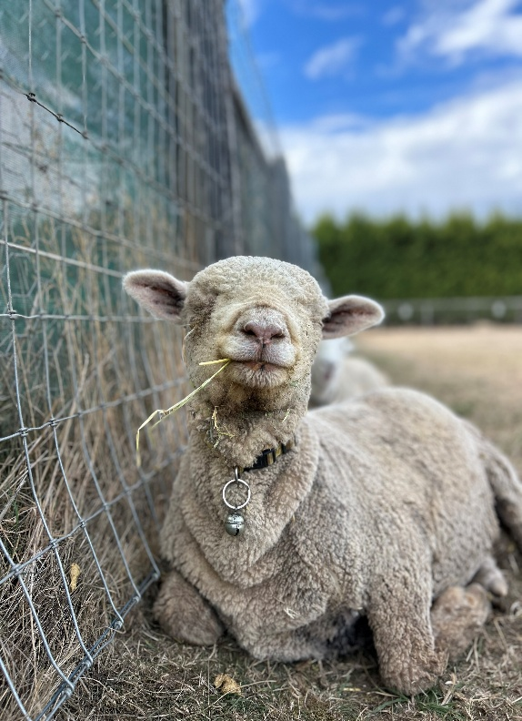
Photo of Cherokee, courtesy of Edgar’s Mission

Registrations are now open for the third biennial AALTRA conference.

Join animal law experts from the Asia-Pacific region for two days of dynamic and innovative discussions on justice for animals.
The conference will be held at the University of Technology Sydney (UTS), 26-27 November 2026 and has been organised by AALTRA (Australasian Animal Law Teachers’ and Researchers’ Association Inc) in conjunction with the Faculty of Law, UTS.
Please complete the registration form on page 3 and email it to Sophie.riley@uts.edu.au Payment should be made directly into AALTRA’s bank account at the same time as the registration application is completed: AALTRA Inc 062-016 1189 8383

Draft Programme at a Glance
Thursday 26 November
11.00 am. Registration and lunch
12.45 p.m. Welcome to the Conference (Ass/prof Sophie Riley)
Welcome to Country, Michael West, Custodian from the Metropolitan Local Aboriginal Land Council
12.55 p.m. Keynote address: by Professor Danielle Celemajer, University of Sydney
1.45 p.m. First Panel - Updates on Australian, NZ and Chinese animal law, Dr Jed Goodfellow, Ass/prof Marcelo Rodriguez Ferrere and Professor Amanda Whitfort (to be confirmed), Facilitator: Ass/prof Sophie Riley
2.45 p.m. Afternoon tea
3.00 p.m. Paper Session, Chair: Ass/prof Jane Kotzman.
5.00 p.m. AGM (AALTRA members only)
5.30 p.m. Award of Prizes
- RSPCA AUSTRALIA, Sybil Emslie Animal Law Scholarship
- VOICELESS, Brian Sherman Animal Law Prize
- AALTRA, AALTRA Research Prize

Friday 27 November
9.00 a.m. Welcome TBA
9.30 a.m. Paper Session, Chair: Ass/prof Marcelo Rodriguez Ferrere
11.30 a.m. Morning tea
11.45 a.m. Panel discussion – Animals and new/emerging/transformative technologies. Panellists TBA. Facilitator: Professor Christine Parker
1.00 p.m. Lunch and farewell
2.00 p.m. Close

AALTRA 2026 CONFERENCE REGISTRATION FORM
(please complete this page to sophie.riley@uts.edu.au)

Title:
Given Name:
Surname:
Organisation:
Job/Title:
Email Address:
Details for receipt:
Name:
Address:

Dietary/Special Requirements (the venue is accessible):
Registration Category:
Registration Categories (fees all in Australian Dollars):
Early Bird Registration – up to 14 August 2026
Category A – Early Bird Academics $150
Category B – Early Bird Industry/NGOs $100
Category C – Student $ 50

Ordinary Registration – After 14 August 2026
Category D – Academics $170
Category E – Bird Industry/NGOs $120
Category F – Student $ 50

The first 30 people who register will receive a shopping tote which they can pick up at the conference. Examples are on the next page. There are only one or two bags of each design. First come first served, please indicate first and second choice.
Tote Design:

TOTE DESIGNS





Lady with Dog Cat with Coffee 1 Dachshund Cat with coffee 2





Route 66 Blue Dinosaur Blue Bee Dragon


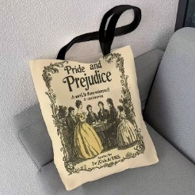



Mozart and friends Pride and Prejudice 1 Girls will be Girls Pride and Prejudice 2
on Abbey Rd






Feline starry night Barn owl Kiwi Black Sheep





Silver Fern Audrey Dalmatian A Whale of a Time Renard

